Design Project Report

*On*

*Shipment Price Prediction*

In Subject: Design Project

By

|  |  |  |
| --- | --- | --- |
| Name | PRN | Roll no. |
| Amey Bhirange | 22110073 | 373005 |
| Saloni Dhurandkar | 22110034 | 373012 |
| Nikhil Dongare | 22110412 | 373015 |
| Shreyas Kharche | 22110063 | 373022 |

Under Guidence : Prof. Mandar Divekar



Department of Artificial Intelligence and Data Science VIIT

**2023-2024**

|  |  |  |
| --- | --- | --- |
| **Sr . no** | **TOPIC** | **Page No.** |
| 1.1 | Introduction , Problem Statement, About the Dataset | 4 |
| 1.2 | Motivation , Gap Analysis, Objective | 5 |
| 1.3 | Literature Survey | 6, 7,8,9,10 |
| 1.4 | Requirements , Scope of Work | 11 |
| 2.1 | UML Diagram | 12 |
| 2.2 | System Architecture | 13 |
| **Conclusion** | | 13 |
| **References** | | 13 |

# Introduction

Shipment price predictive forecasting uses statistical techniques and machine learning to predict future prices based on historical data. It assists in understanding past trends, enhancing decision-making for cash flow, risk assessment, capacity planning, and meeting customer demands in the supply chain.

## Problem Statement:-

## To provide a methodological approach to analyze the ongoing trends and predicting the future price of shipment packages based on various factors which affect the pricing. This prediction is to be done using the machine learning models.

## About the Dataset :-

* This data set provides supply chain health commodity shipment and pricing data.
* This dataset provides a more complete picture of global spending on specific health commodities.
* Supply chain leaders may use this data to address supply chain difficulties, cut costs, and enhance service levels all at the same time.
* This dataset is taken from U.S agency for international Development

Dataset Link :

<https://data.usaid.gov/HIV-AIDS/Supply-Chain-Shipment-Pricing-Data/a3rc-nmf6>

## Motivation :-

## Vital SCM Growth: SCM is crucial for industries, with rapid growth due to increasing product demand.

## Shipment Forecasting's Role: Shipment Forecasting reveals supply chain insights, enabling data-driven decisions.

## Resilience and Future Focus: It helps SCM overcome challenges, adapt to disruptions, and thrive in a data-driven future.

**Gap Analysis :-**

1. Limited Utilization of Advanced Techniques :-

Gap: Many SCM organizations still rely on outdated forecasting methods, missing out on the benefits of advanced statistical techniques and machine learning.

Opportunity: Embracing predictive analytics can improve shipment forecast accuracy, enabling better-informed decisions.

1. Capacity and Workflow Optimization :-

Gap: Capacity planning and workflow optimization often depend on static historical data and rule-based systems that don't adapt in real-time.

Opportunity: Shipment forecasting offers dynamic insights for agile and efficient operations, bridging this gap.

**Objective :-**

The primary goal of this project is to develop an advanced shipment forecasting system tailored to the needs of the supply chain management (SCM) sector. This system aims to empower organizations by helping them adapt to -

1. supply chain variations

2. increase logistic efficiency

3. make data-driven decisions

By implementing advanced analytics, the project seeks to support industry growth, mitigate financial risks, and ultimately enhance operational excellence, thereby ensuring the competitiveness of organizations in the SCM industry.

**Literature Survey :-**

|  |  |  |  |
| --- | --- | --- | --- |
| Research Paper | Name of Author | Methodology | Link |
| Shipment Price Forecasting | Mohamed Illiyas I | Forecasting helps predict short and long-term prices and their underlying drivers. Customer satisfaction is crucial for growth. To keep customers happy, provide the right product at the right time, avoiding overcharging due to demand and supply. Price forecasting minimizes unnecessary shipping costs, lowering product prices and increasing customer satisfaction. | <https://www.linkedin.com/posts/mohamed-illiyas_supply-chain-shipment-pricing-forecasting-activity-6880766053572599808-zu0R/> |
| Predictive Big Data Analytics for Supply Chain | Mahya Seyedan  &  Fereshteh Mafakheri | Big data analytics (BDA) is increasingly important in supply chain management (SCM), with applications including customer behavior analysis, trend analysis, and demand prediction. This survey categorizes BDA applications for supply chain demand forecasting into various methods and points out a research gap in applying BDA to closed-loop supply chains (CLSCs), offering suggestions for future research. | <https://journalofbigdata.springeropen.com/articles/10.1186/s40537-020-00329-2> |
| Forecasting the Spot Price of P1A Shipping Route | Panagiota Giannakopoulou | This project has two main objectives. First, it aims to identify the financial and shipping measures that significantly impact the estimation of the daily spot voyage time charter price for the P1A Panamax shipping route, as reported by the Baltic Exchange in London. Second, it seeks to evaluate the predictive capabilities of multivariate feature models and single-variable time series models to forecast the future voyage time charter price for the P1A shipping route. | [Forecasting the Spot Price of P1A Shipping Route | IEEE Conference Publication | IEEE Xplore](https://ieeexplore.ieee.org/document/9010591) |
| IRAS | Karthik Sonti,  Daisuke Tsukamoto | Accenture Intelligent Revenue and supply chain (IRAS) Management is the service developed by Accenture in partnership with Amazon. This platform integrates insights generated by machine learning (ML) and artificial intelligence (AI) models into an enterprise’s technical and business ecosystems. | <https://aws.amazon.com/blogs/apn/optimizing-supply-chains-through-intelligent-revenue-and-supply-chain-iras-management/> |
| Application of machine learning techniques for supply chain demand forecasting | Real Carbonneau  Kevin Laframboise  Rustam Vahidov | This study explores supply chain collaboration challenges and uses advanced machine learning methods, like neural networks and recurrent neural networks, to forecast distorted demand (the bullwhip effect). Traditional methods, such as naïve forecasting and regression, are compared. Results indicate that advanced techniques perform well but not significantly better than regression models. | <https://www.sciencedirect.com/science/article/abs/pii/S0377221706012057> |

## Requirements :-

## Cloud , Python , Flask .

## ML Libraries & Framework.

## Jupyter notebooks , VS Code.

**Scope of work :-**

* Platform Development :- Create a user-friendly web-based platform for Shipment Price Prediction.
* Benchmarking Products :- IRAS empowers supply chain operators with real-time data and forecasting models. IRAS, or Intelligent Revenue and Supply Chain Management, is a platform developed by Accenture in collaboration with Amazon that leverages machine learning and artificial intelligence to optimize supply chain operations.
* Business Opportunity :- Extending this technique to small businesses and logistics firms offers big opportunities, especially with the increasing demand for their products and services.
* Final Product Prototype :- The final product is a service that provides small businesses with detailed information on what pricing to be given for packages in the shipping.

**UML Diagram :-**

Data Flow Diagram :-

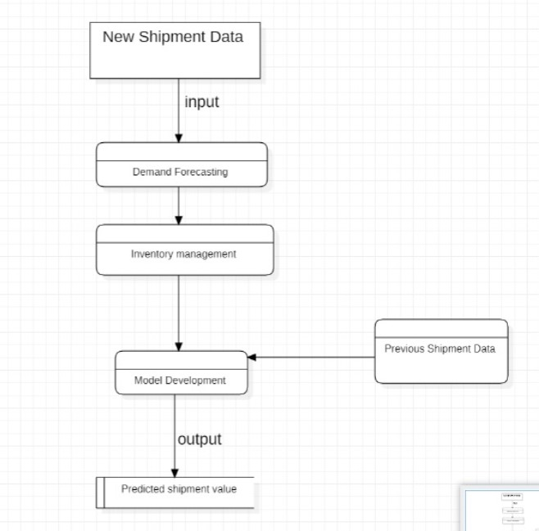

Usecase Diagram :-

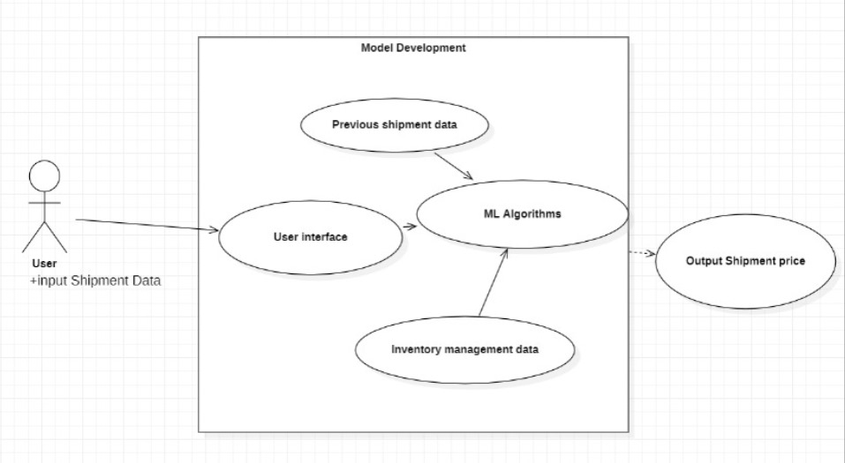

**System Architecture:-**

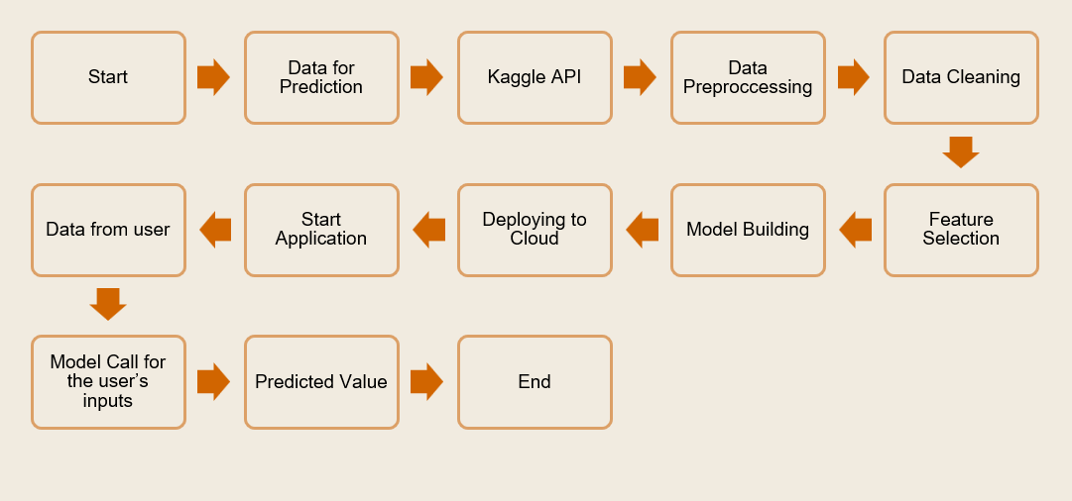

**Conclusion**

AI is changing the way we are. So, we have to move forward to the advanced options to keep our pace in the world. Many organizations are switching to the AI module for their applications.

With the right tools, software and programs, you can develop an automated process that improves

the current pricing and forecast the future pricing.

Hence, I have explained the prototype and concept for the supply chain shipment price forecasting. It has a lot of scope for the current world. This will definitely create a great opportunity to improve the business in logistics, supply chain management and other related firms. The implementation in the real-world scenarios will bring a huge impact in SCM sector.

**References**

1. <https://www.linkedin.com/posts/mohamed-illiyas_supply-chain-shipment-pricing-forecasting-activity-6880766053572599808-zu0R/>
2. <https://journalofbigdata.springeropen.com/articles/10.1186/s40537-020-00329-2>
3. <https://aws.amazon.com/blogs/apn/optimizing-supply-chains-through-intelligent-revenue-and-supply-chain-iras-management/>
4. [Forecasting the Spot Price of P1A Shipping Route | IEEE Conference Publication | IEEE Xplore](https://ieeexplore.ieee.org/document/9010591)
5. <https://www.sciencedirect.com/science/article/abs/pii/S0377221706012057>